Title: Game Content Creation Assignment #3

Name:- Krish K. Jani

Course:- GAM536 NZA

Date:- 9th August, 2024

Prof. Name:- Georgios Kougioumtzoglou

|  |
| --- |
| Table of content |
| A train ride with atleast one stop |
| An animated plane ride |
| A castle |
| Appropriate fencing |
| Water-feature |
| Lights |
| Gates with good outlook |

Below are the detailed screenshots of my 3D Animation Project, showcasing the various stages of development along with descriptions of how the specified functionalities were achieved.

So here is a overview of my amusement park

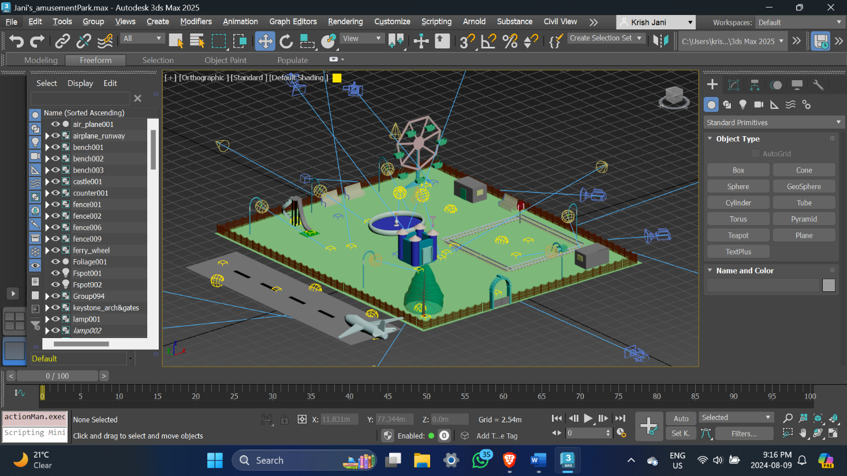

Over here is a air-plane ride. This plane takes off, flies around the park and lands on the runway.

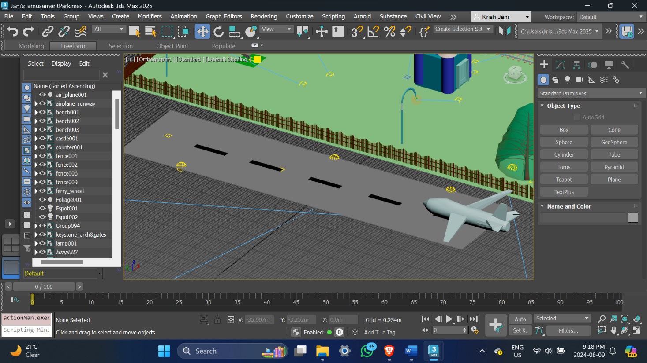

As we can see here is a slide and has benches and street lights near a water fountain.

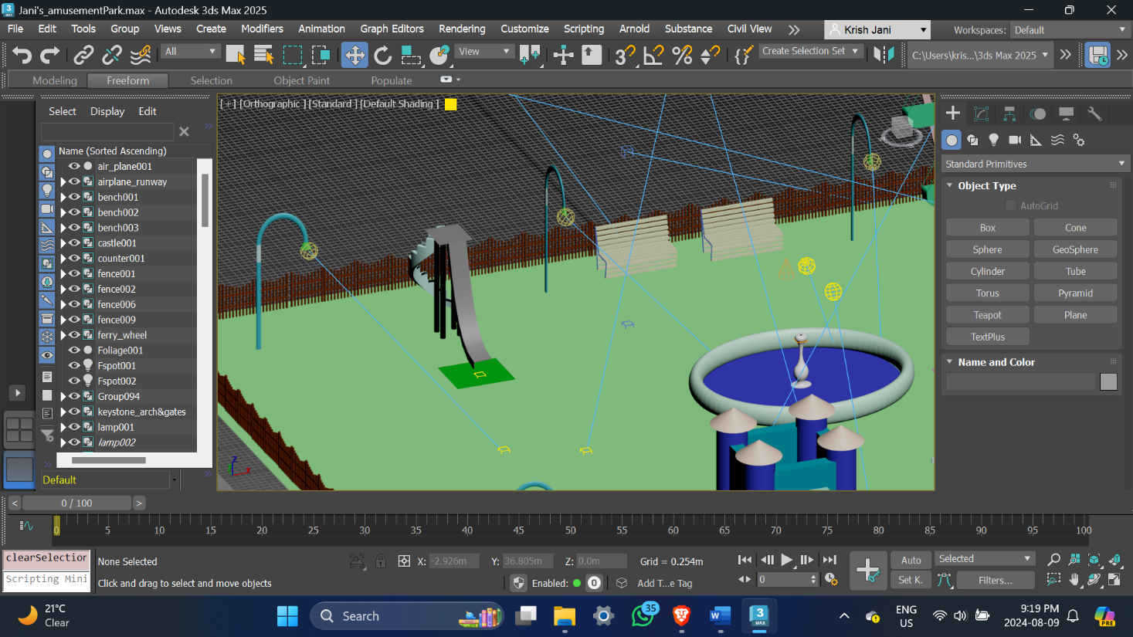

I made a ferry wheel and it has a ticket counter in front of it to purchase its tickets.

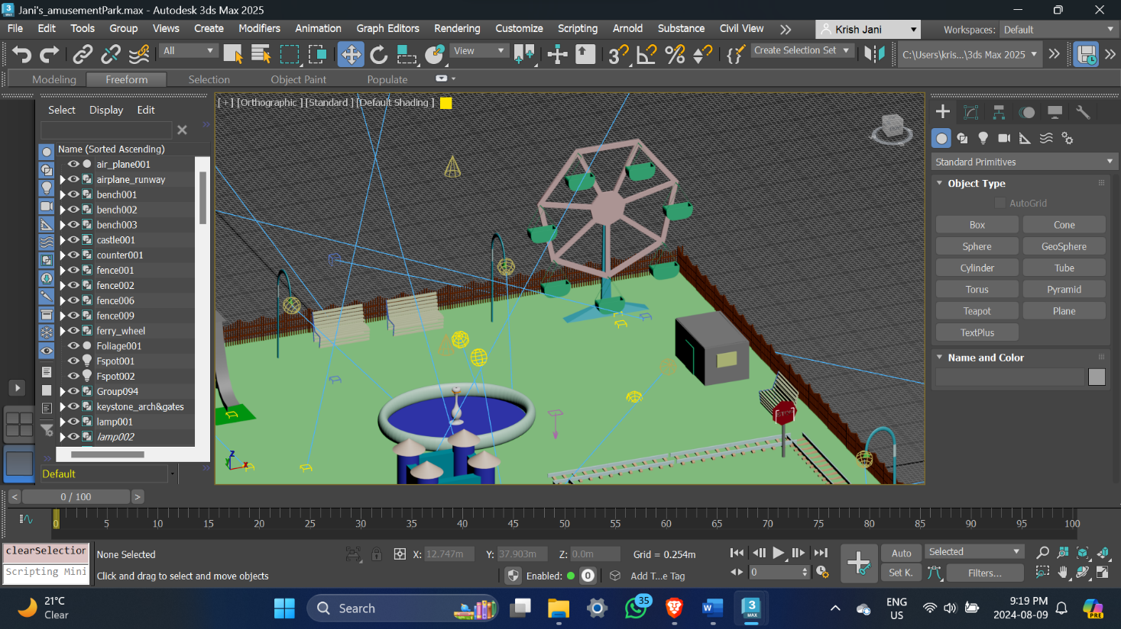

Here is the castle, I rebuilt it to match it with the rest park.

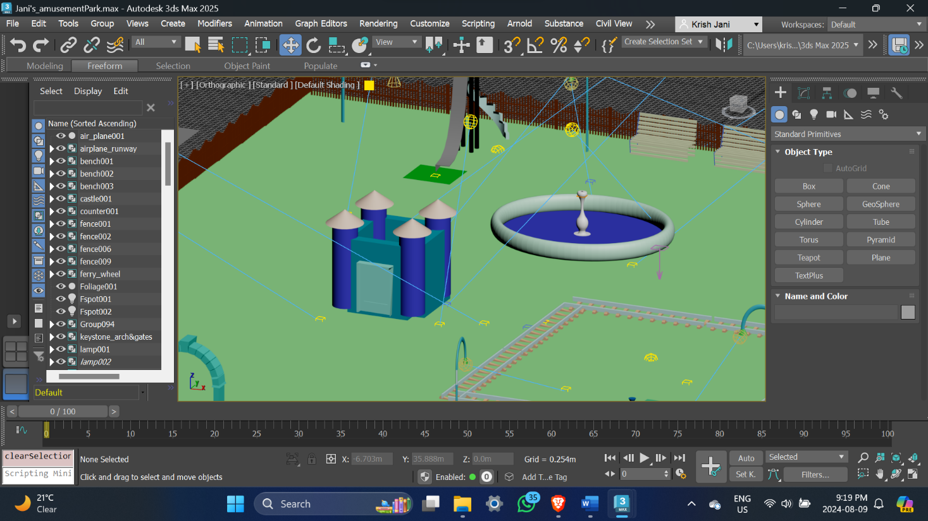

Here we have a train which runs on the tracks and it has a ticket counter besides it and also a stop sign where the train stops for a few seconds along the way.

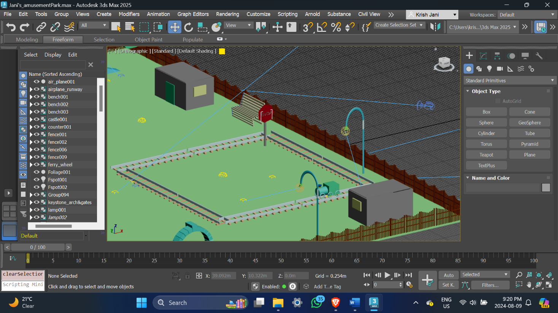

The train as mentioned above stops for a few seconds as we can see in the screenshot.

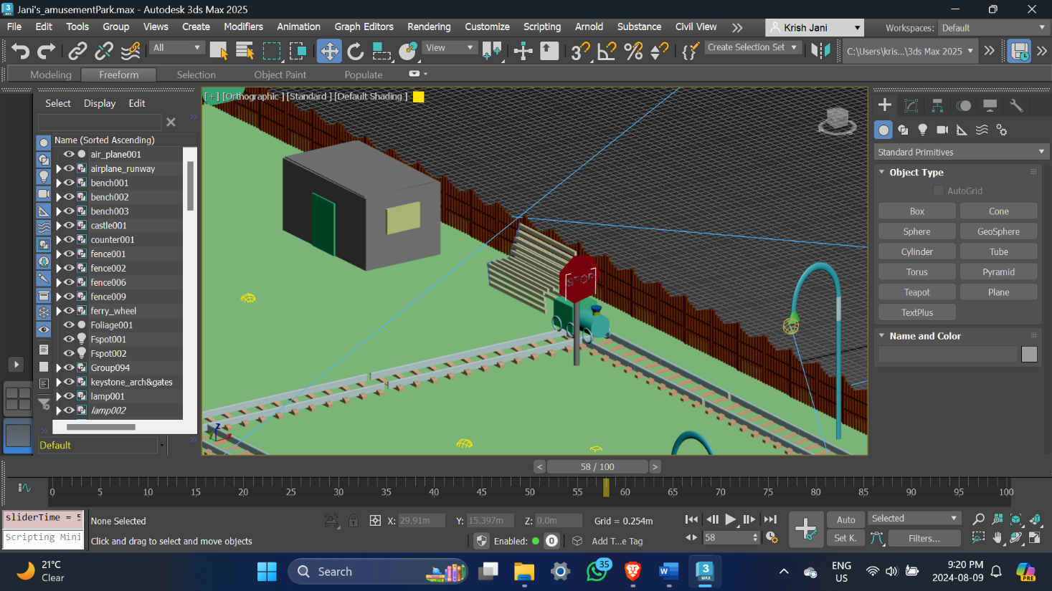

This is the water fountain and we have benches nearby where people can sit and have fun watching the fountain and the whole park

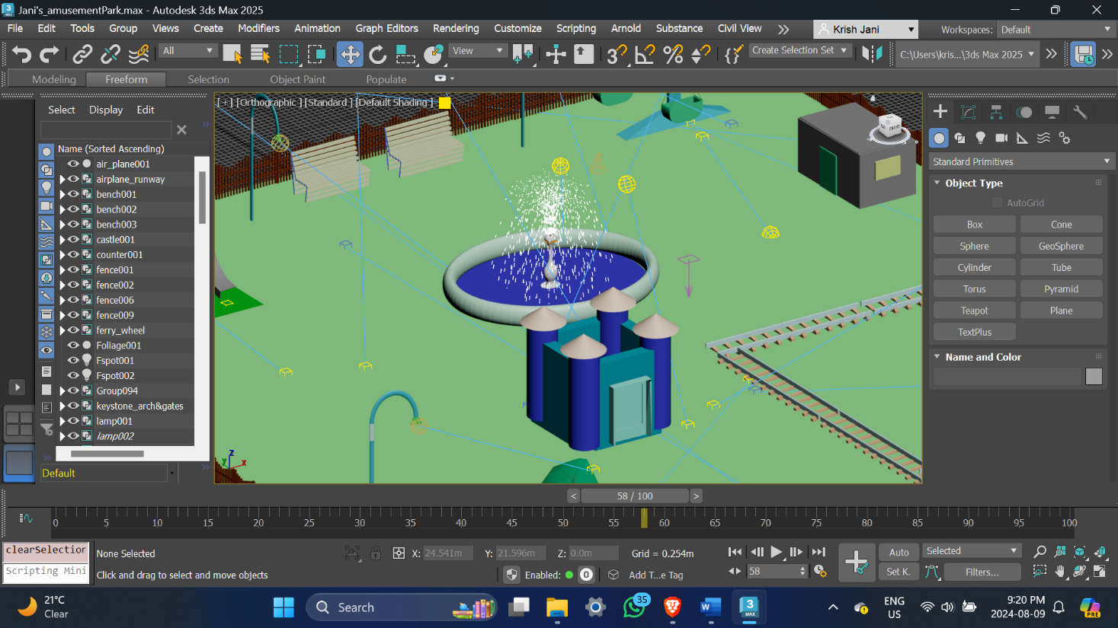

This is the overview of the park where the plane is in the air as we can see.

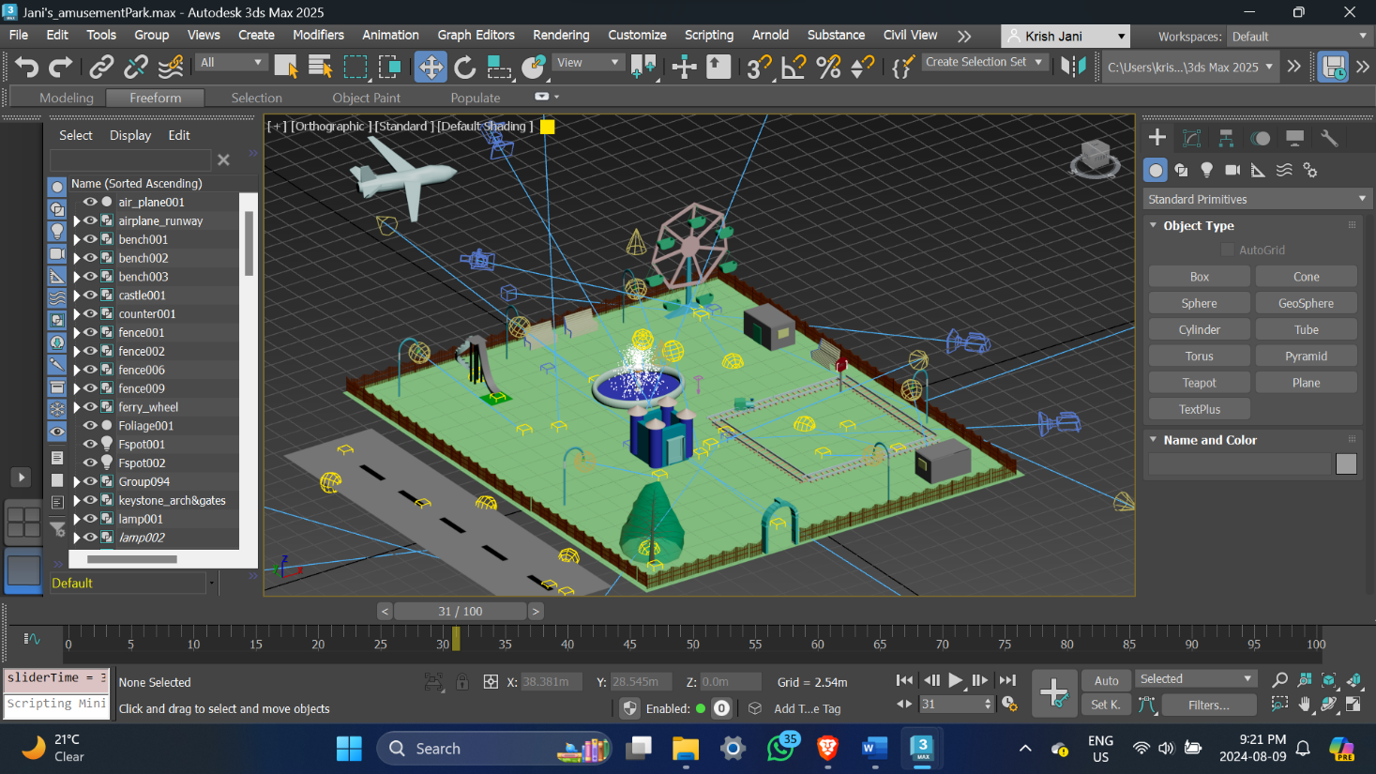

Also I have made appropriate fencing all around the park as we can see in almost all the screenshots.

In accordance with the assignment requirements, I have ensured that all specified functionalities are fully implemented in my 3ds Max amusement park project. I have put forth my best effort to create an engaging and visually appealing park, paying close attention to both major attractions and the finer details. I have also gone the extra mile to incorporate additional elements, even the smallest features, to enhance the overall experience. I sincerely hope that the effort and creativity invested in this project are evident, and that you find the final result enjoyable and immersive.